# GOVERNMENT POLYTECHNIC COLLEGE MATTANNUR-670702

### (Department of Technical Education, Kerala)



**SEMINAR REPORT ON**

**OPTOELECTRIC NUCLEAR BATTERY**

**SUBMITTED BY ATHUL U K**

**(Reg.No:19041651)**

**DEPARTMENT OF ELECTRONICS ENGINEERING**

**2021-22**

**GOVERNMENT POLYTECHNIC COLLEGE MATTANNUR-670702**

**(Department of Technical Education, Kerala)**



**CERTIFICATE**

*Certified that seminar work entitled* “***OPTOELECTRIC NUCLEAR BATTERY*”***is a bonafide work carried out by* **“*ATHUL U K* ”** *in partial fulfilment for the award of Diploma in Electronics Engineering from Government Polytechnic College Mattannur during the academic year* 2021-2022.

### Seminar Co-ordinator Head of Section

**Internal Examiner External Examiner**

**DECLARATION**

I hereby declare that the report of *the* ***OPTOELECTRIC NUCLEAR BATTERY*** work entitled which is being submitted to the Govt. Polytechnic College Mattannur, in partial fulfilment of the requirement for the award **of *Diploma in Electronics Engineering*** *i*s a confide report of the work carried out by me. The material in this report has not been submitted to any institute for the award of any degree.

Place:Mattannur **ATHUL U K**

### ACKNOWLEDGEMENT

I would like to take this opportunity to extend my sincere thanks to people who helped me to make this seminar possible. This seminar will be incomplete without mentioning all the people who helped me to make itreal.

Firstly, I would like to thank GOD, almighty, our supreme guide, for bestowing his blessings upon me in my entire endeavor.

I would like to express my deepest gratitude **Mr. M C PRAKASHAN** (Principal GPTC, Mattannur), **Mr. GEORGE KUTTY P P (**Head of Department of Electronics Engg.), for the help rendered by him to prepare and present this Seminar in proper way. Moreover I am very much indebted to **Mr. SREEJITH A** (Lecturer, Electronics Engg, seminar co-ordinator), for their advice.

I am also indebted to all my friends and classmates who have given valuable suggestion and encouragement.

**ATHUL U K**

**ABSTRACT**

An optoelectric nuclear battery (also radio photovoltaic device, radio luminescent nuclear battery or radioisotope photovoltaic generator) is a type of nuclear battery in which nuclear energy is converted into light, which is then used to generate electrical energy. This is accomplished by letting the ionizing radiation emitted by the radioactive isotopes hit a luminescent material (scintillator or phosphor), which in turn emits photons that generate electricity upon striking a photovoltaic cell. The potential of this battery for longer shelf-life and higher energy density when compared to other modes of energy storage make them attractive alternative to investigate. It is a non-thermal type nuclear battery. Nuclear batteries use the incredible amount of energy released naturally by tiny bits of radioactive material without anyfission or fusion taking place inside the battery. These devices use thin radioactive films that pack in energy at densities thousands of times greater than those of lithium-ion batteries. Because of the high energy density nuclear batteriesare extremely small size.

TABLE OF CONTENTS

**CHAPTERNO TOPICS PAGENO**

Chapter1 INTRODUCTION……………………………………...8

Chapter2 TYPES OF NUCLEAR BATTERY...………………….9

Chapter2.1 THERMAL……………………………………..............9

Chapter2.2 NON-THERMAL…...………………….…….…….…..9

Chapter3 COMPONENTS OF OPTOELECTRIC NUCLEAR BATTERY………………………...………………..….10

Chapter3.1 DUST PLASMA…………………………………….....11

Chapter3.2 PHOTO VOLTAIC LAYER…………..………….…...13

Chapter4 RADIO ACTIVE DECAY………..….. ………….…...14

Chapter5 WORKING…………………………..….…………..…15

Chapter6 APPLICATIONS………………………………………16

Chapter6.1 SPACE APPLICATIONS…………………….…….....16

Chapter6.2 MEDICAL APPLICATIONS……………………..…..16

Chapter6.3 MILITARY APPLICATIONS…..……………...….….18

Chapter7 ADVANTAGES………..……………………………...19

Chapter8 DISADVANTAGES…………...……………..……….20

Chapter9 CONCLUSION……………………………..………....21

Chapter10 REFERENCE………………………………………….22

|  |  |  |
| --- | --- | --- |
| **FIGURE NO** | **LIST OF FIGURES**  **NAME** | **PAGE NO** |
| Fig 3.1 | BETA DECAY……………………………....... | 12 |
| Fig 3.2 | PHOTO VOLTAIC LAYER……………..……….. | 13 |
| Fig 4.1 | RADIO ACTIVE DECAY………………….…….. | 14 |
|  |

**CHAPTER 1**

**INTRODUCTION**

A nuclear battery is a device includes a radiation source that acts in conjuction with a transducer which converts decay energy into an electric current. Like nuclear reactors they generate electrical energy from nuclear energy. Nuclear battery has two conversion techniquesthermal and non-thermal. An optoelectric nuclear battery has been developed by researchers of the Kurchatov institute in Moscow. Optoelectric nuclear battery is grouped into non-thermal converters. In optoelectric nuclear battery nuclear energy is converted in to light,which is then used to generate electrical energy. Chemical batteries require frequent replacement and are bulky. Fuel and solar cells are expensive and requires sunlight respectively. Thus demand to exploit the radioactive energy has become inevitably high. Unlike conventional nuclear power generating devicesthe power cells do not rely on a nuclear reaction or chemical process do not produce radioactive waste products

**CHAPTER 2**

**TYPRS OF NUCLEAR BATTERY**

Broadly classified in to

**2.1 Thermal**

a) Thermionic converter: It consists of a hot electrode which thermionically emits electrons over a potential energy barrier to a cooler electrode, producing a useful electric power output.

b) Radioisotope thermoelectric generator: It uses an array of thermocouples to convert the heat released by the decay of a suitable radioactive material into electricity by the seebeck effect.

c) Thermo photovoltaic cell: Thermo photovoltaic energy is a direct conversion process from heat to electricity via photons.

d) Alkali-metal thermal to electric convertor: It is a thermally regenerative electrochemical devicefor the direct conversion of heat to electrical energy.

e) Stirling radioisotope generator: The hot end of stirling convertor reaches high temperature and heated helium drives the piston, with heat being rejected at the cold end of the engine. A generator or alternator converts the motion into electricity.

**2) Non-thermal**

a) Direct charging generators: This method makes use of kinetic energy as well as the magnetic property of alpha particles to generate current.

b) Beta voltaics: They are generators of electrical current, in effect a formof battery, which uses energy from a radioactive source emitting beta particles.

c) Alpha voltaics: Alpha voltaic power generators are devices that use a semiconductor junction to produce electrical particle from energetic alpha particles.

d) Optoelectric: A beta-emitter would stimulate an excimer mixture,and the light would power a photocell.

e) Reciprocating electromechanical atomic batteries: They use the build up of charge between 2 plates to pull one bendable plate towards the other, until the two plates touch, discharge, equalizing the electrostatic buildup, and spring back. The mechanical motion produced can be used to produceelectricity through flexing of piezoelectric material or through a linear generator.

**CHAPTER 3**

**COMPONENTS OF OPTOELECTRIC**

**NUCLEAR BATTERY**

**3.1 Dust plasma**

A dusty plasma is a plasma containingmicrometer (10−6) to nanometer (10−9) sized particles suspended in it. Dust particles are charged and the plasma and particles behave as a plasma. Dust particles may form larger particles resulting in "grain plasmas". Due to theadditional complexity of studying plasmas with charged dust particles, dusty plasmas are also known as complex plasmas. It consists of beta-emitters and excimers in optoelectric nuclear battery.

a) Beta-emitter Beta particles are high-energy, high-speed electrons or positrons emitted by certain typesof radioactive nuclei such as potassium-40. The betaparticles emitted are a form of ionizing radiation also known as beta rays. The production of beta particles istermed beta decay. They are designated by the Greek letter beta (β). There are two forms of beta decay, β− and β+ , which respectively give rise to the electron and the positron. β− decay (electron emission):

An unstable atomic nucleus with an excess of neutrons may undergo β− decay, where a neutron is converted into a proton, an electron and an electron-type antineutrino (the antiparticle of the neutrino).

n 🡪 p + e- + -ve

This process is mediated by the weak interaction. The neutron turns into a proton through the emission of a virtualW− boson. At the quark level, W− emission turns a down- type quark into an up-type quark, turning a neutron (one up quark and two down quarks) into a proton (two up quarks and one down quark). The virtual W− boson then decays into an electron and an antineutrino.

Beta decay commonly occurs among the neutron-rich fission byproducts produced in nuclear reactors. Free neutrons also decay via this process. This is the source of the copious amount of electron antineutrinos produced by fission reactors. β+ decay (positron emission):

Unstable atomic nuclei with an excess of protons mayundergo β+ decay, also called inverse beta decay, where a proton is converted into a neutron, a positron and an electron-type neutrino:

P 🡪 n + e+ + ve

Beta plus decay can only happen inside nuclei when the absolute value of the binding energy of the daughter nucleus is higher than that of the mother nucleus. Inverse beta decay is one of the steps in nuclear fusion processes that produce energy inside stars.

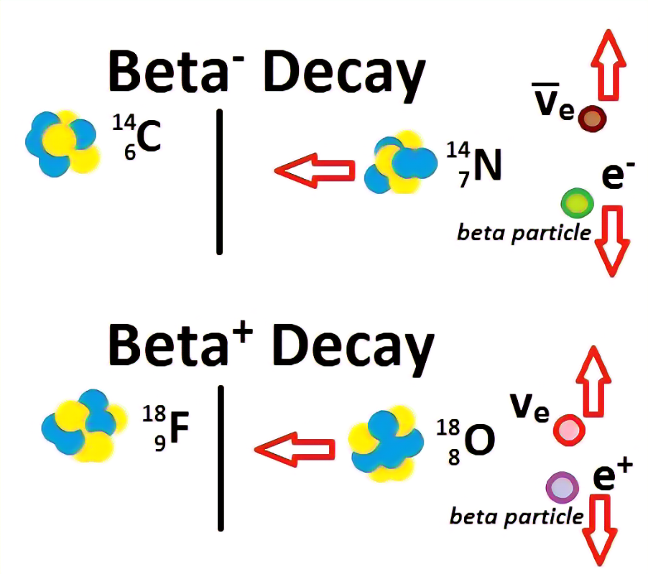

Fig3.1 Beta decay

a) Excimers

An excimer (originally short for excited dimer) is a short-lived dimeric or heterodimeric molecule formed from two species, at least one of which is in an electronic excitedstate. Excimers are often diatomic and are formed between two atoms or molecules that would not bond if both were in the ground state. The lifetime of an excimer is very short, on the order of nanoseconds. Binding of a larger number of excited atoms form Rydberg matter clusters the lifetime of which can exceed many seconds.

**3.2 Photovoltaic layer**

A Photovoltaic layer is an energy harvesting technology, that converts solar energy into useful electricity through aprocess called the photovoltaic effect. There are several different types of PV layers which all use semiconductors to interact with incoming photons from the object in order to generate an electric current.

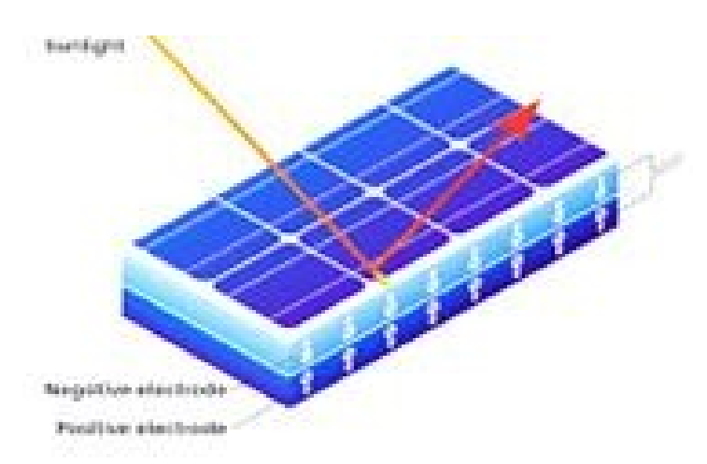

Fig 3.2 Photo voltaic layer

**CHAPTER 4**

**RADIO ACTIVE DECAY**

Radioactive decay is the emission of energy in the form of ionizing radiation. The ionizing radiation that is emitted can include alpha particles, beta particles and/or gamma rays.Radioactive decay occurs in unbalancedatoms called radionuclides.

Elements in the periodic table can take on several forms. Some of these forms are stable; other forms are unstable. Typically, the most stable form of an element is the most common in nature. However, all elements have an unstable form. Unstable forms emitionizing radiation and are radioactive. There are some elements with no stable form that are always radioactive, such as uranium. Elements that emit ionizing radiation are called radionuclides.

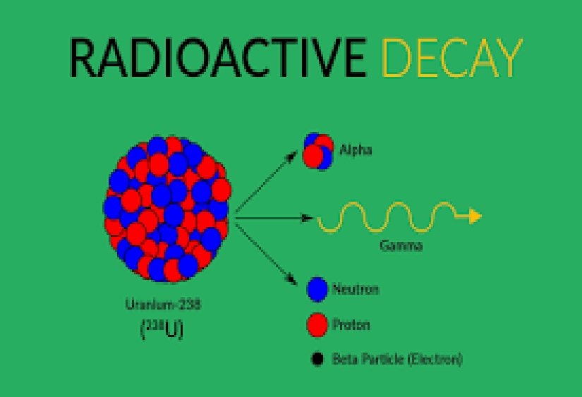

Fig 4.1 Radioactive decay

**CHAPTER 5**

**WORKING**

An optolectric nuclear battery has been developed by researchers of the Kurchatov Institute in Moscow. A beta- emitter such as technetium-99 or strontium-90 is suspended in a gas or liquid containing luminescent gas molecules of the excimer type, constituting a "dust plasma." This permits a nearly lossless emission of beta electrons from the emitting dust particles for excitation of the gases whoseexcimer line is selected for the conversion of the radioactivity into a surrounding photovoltaic layer such that a comparably light weight low pressure, high efficiency battery can be realised.

These nuclides are low cost radioactive waste of nuclear power reactors. The diameter of the dust particles is so small (a few micrometers) that the electrons from the beta decay leave the dust particles nearly without loss. The surrounding weakly ionized plasma consists of gases or gas mixtures (e.g. krypton, argon, xenon) with excimer lines, such that a considerable amount of the energy of the beta electrons is converted into this light. Thesurrounding walls contain photovoltaic layers with wide forbidden zones as 3.g. diamond which convert the optical energy generated from the radiation into electric energy

**CHAPTER 6**

**APPLICATIONS**

Nuclear batteries find many fold applications due to its long life time and improved reliability .In the ensuring era,the replacing of conventional chemical batteries will be of enormous advantages .This innovative technology will surely bring break-through in the current technology which was muddled up in the power limitations .

**6.1 Space applications**

In space applications, nuclear power units offer advantages over solar cells, fuel cells and ordinary batteries because of the following circumstances

When the satellite orbits pass through radiation belts such as the van-Allen belts around the earths that could destroy the solar cells . Operations on the Moon or Mars where long periods of darkness require heavy batteries to supply power than solar cells would not have access to sunlight. Space missions in the opaque atmospheres such as Jupiter, where solar cells would be useless because of lack of light . At s distance far from the sun for log duration missions where solar cells, batteries and solar arrays would be too large and heavy . Heating the electronics and storage batteries in the deep cold of space at minus 245digree F is a necessity so in the future it did ensured that these nuclear batteries replace all the existing p[ower supplies due to it’s incredible advantages over the others . The applications which require a high life time, a compact design over density , an atmospheric conditions independent it is quite a sure shot that future will be of ‘Nuclear Batteries’ .NASA is on the hot pursuit of harnessing this technology in space applications

**6.2 Medical Applications**

The medical field finds a lot of applications with the nuclear batteries due to their increased longevity and better reliability . It would be suited for medical devices like pacemakers, implanted deep fibrillators or other implanted devices that would otherwise require surgery to replace or repair the best out of the box is use in “Cardiac pacemakers” .Batteries used in implementable cardiac pace makerspresent unique challenges to their developers and manufactures in terms of high levels of safety and reliability and it often poses threat to the end-customer . In addition, the batteries must have longevity to avoid frequent replacement. The technological advance in leads/electrodes have reduced energy requirements by two order of magnitude. Microelectronics advances sharply reduce internal current drain, concurrently decreasing size and increasing functionality , reliability and longevity . It is reported that about 600,000 pacemakers are implanted each year worldwide and total number of people with various types of implanted pacemakers has already crossed 3,000,000 . A cardiac pacemaker uses half of it’s battery power for cardiac stimulation and the other half for house keeping tasks such as monitoring and data logging . The first implemented cardiac pacemaker used nickel-cadmium rechargeable battery . Latter on zinc-mercury battery was developed and used which last for over two years . Lithium iodide battery , developed in 1972 made the real impact to implantable cardiac pacemakers and is on the way. But it draws the serious threats last for about ten years and this is a serious problem . The life time solution is nuclear battery.

Nuclear batteries are the best reliable and it last lifetime. The definitions for some of the important parts of the battery and its performances are pacemakers like voltage, duty cycle , temperature , shelf life , service life, safety and reliability ,internal resistance, specific energy (watt-hour/kg), specific power(watts/kg),and in all that means nuclear batteries stands out . The technical advantage of nuclear batteries are in terms of it’s longevity, adaptable shapes and sizes,corrosion resistance, minimum weight,excellent current drain that suits to cardiac pacemakers.

Mobile devices Xcell-n is a nuclear powered laptop battery that can provide between seven and eight thousand times the life of a normal laptop battery-that is five year worth of continues power .Nuclear batteries are about forgetting things around the usual charging ,battery replacing and such bottlenecks . Since chemical batteries are just near the end of their life, we can’t expect much more from them , in it’s lowest accounts , a nuclear battery can endure at least up to five years. The xcell-N is in continuous working for the last eight months and has not been turned off and has never been plugged into electrical power since .Nuclear batteries are going to replace the conventional batteries and adapters, so the future will be of exciting innovative new approach to powering portable devices Automobiles.

Although it is on the initial stages of development, it is highly promised that the nuclear batteries will find a a sure niche in the automobiles replacing the weary conventional iconic fuel there will be no case such a running out of fuel and running out of fuel and running short of time . ‘Fox valley auto association USA’ already conducted many seminars on the scopes and they are on the way of implementing this. Although the risks associated the usage of nuclear battery , even concerned with legal restriction are of many , but its advantages over the usual gasoline fuels are overcoming all the obstacles .

**6.3 Military Applications**

The army is undertaking a transformation into a more responsive, deployable, ans sustainable force , while maintaining high levels of lethality, survivablelity and versatility In unveiling the strategy , the final resource that fit quite beneficial is ‘nuclear battery’ “TRACE photonics, U.S Army Armaments Research ,Development and Engineering Centre”has harnessed radioisotope power source to provide very high energy density battery power to the men in action . Nuclear batteries are much lighter than chemical batteries and will last years, even decades . No power cords or transformers will be needed for the next generation of micro electronics in which voltage-matched supplies are built into components . Safe,long-life, reliable and stable temperature is available from the direct conversion of radioactive decay energy to electricity . This distributed energy source is well suited to active radio frequency equipment tags, sensor and ultra wide-band communication chips used on the modern battlefields.

**CHAPTER 7**

**ADVANTAGES**

The most important feat of optoelectric nuclear cells is the life span they offer,a minimum of 10 years . This is whopping when considered that it provides non stop electric energy for the seconds spanning these 10 long years, which may supply mean that we keep our laptop or any hand held devices switch-on for 10 years non-stop. Contrary to fears associated with conventional batteries nuclear cells offer reliable electricity, without any drop in the yield or potential during its entire operation period. Thus the longevity and reliability coupled together would surface the small factored energy needs for at least a couple of decades

The large concern of nuclear batteries comes from the fact that it involves the use of radioactive materials. This means throughout the process of making a nuclear battery to final disposal, all radiation protection standards must be met. Balancing the safety measures such as shielding and regulation while still keeping the size and power advantages will determine the economic feasibility of nuclear batteries . Safeties with respect to the containers are also adequately taken care as the battery cases are hermetically sealed . Thus the risk of safety hazards involving radioactive materials stands reduced

As the energy associated with fissile material is several times higher than conventional sources, the cells are comparatively much lighter and thus facilitates high energy densities to be achieved. Similerly, the efficiency of such cells is much higher simply because radioactive materials in little waste generation. Thus substituting the future energy needs with nuclear cells and replacing the already existing ones with these,the world can be seem transformed by reducing the green house effect and associated risks. This should come as a handy savior for almost all developed and developing nations. Moreover the nuclear produced therein are substances that don’t occur naturally. For example strontium does not exist in nature but it is one of the several radioactive waste products resulting from nuclear fission.

**CHAPTER 8**

**DISADVANTAGES**

A failure of containment would release high-pressure jets of finely-divided radioisotopes, forming an effective dirty bomb. First and foremost , as is the case with most breathtaking technologies, the high initial cost of production involved is a drawback but as the product goes optional and gets into bulk production , the price is sure to drop . The size of nuclear batteries for certain specific applications may cause problems, but can done away with as time goes by. For example size of Xcell used for laptop battery is much more than the conventional battery used in laptops.

Through radioactive materials sport high efficiency , the conversion methodologies used presently are not much of any wonder and at the best matches conventional energy sources . However , laboratory results have yielded much higher efficiencies, but are yet to be released into the alpha stage.

A minor blow may come in the way of existing regional and country specific laws regarding the use of disposal of radioactive materials . As these are not unique worldwide and are subject to politicall horrors and ideology prevalent in country. The introduction legally requires thes to be scrapped or amended . It can be however be hoped that , given the revolutionary importance of the substance , things would come in favor gradually .

Above all , to gan social acceptance , a new technology must be beneficial and demonstrate enough trouble free operation that people begin to see it as “normal” phenomenon .Nuclear energy began to loose this status following a series of major accidents in its formative years. Acceptance accorded to nuclear power should be trust-based rather than technology based . In other words acceptance might be released to public trust of organizations and individuals utilizing the technology as opposed to based on understanding of the available evidence regarding the technology

**CHAPTER 9**

**CONCLUSION**

The world of tomorrow that science fiction dreams of technology manifests might be a very small one. It would reason that small devices would need small batteries to power them. The use of power as heat and electricity from radioisotope will continue to be indispensible. As the technology grows, the need for more power and more heat will undoubtedly grow alongwith it.

The principal concern of optoelectric nuclear batteries comes from the fact that it involves the use of radioactive materials. With several features being added to this little wonder and other parallel laboratory works going on, optoelectric nuclearbatteries are going to be the next best thing ever invented in the human history.

**CHAPTER 10**

**REFERENCES**

* <https://www.chemeurope.com/en/encyclopedia/Optoelectric_nuclear_battery.html>
* <https://en.wikipedia.org/wiki/Optoelectric_nuclear>

_battery#As_a_DIY_project

* <https://www.slideshare.net/asertseminar/nuclear-battery-ppt-3216181>